Források:

<https://encrypted-tbn0.gstatic.com/images?q=tbn:ANd9GcRY9Ilh6CT-OlLNmOyPx9eCR7LJcO6uqa8USw&usqp=CAU>

<https://img.freepik.com/free-photo/closeup-shot-doctor-with-rubber-gloves-taking-blood-test-from-patient_181624-56107.jpg?w=1380&t=st=1701427704~exp=1701428304~hmac=dae9ad2af660c9ea042b1896b8ff63038cdc56609258f0833b9f2e1d8a185642>

<https://img.freepik.com/free-vector/allergy-concept-with-risk-factors-symptoms-flat-vector-illustration_1284-30168.jpg>

<https://i1.sndcdn.com/artworks-FRIqYPtESjPf6jwJ-mEXsUg-t500x500.jpg>

<https://cdn1.edgedatg.com/aws/v2/abc/TheGoodDoctor/person/2057161/3b64a2c60ab1522e01e641c6231ced0a/512x288-Q90_3b64a2c60ab1522e01e641c6231ced0a.jpg>

<https://nlc.p3k.hu/uploads/2020/06/dr-bubo.jpg>

<https://www.filmtekercs.hu/wp-content/uploads/2012/07/house-m-d_9fca7df0.jpg>

<https://pixabay.com/get/ge4094271beb06e02d07df55fda4465f57fa650d06f4e33aabb1924941beb6ece784ef6dd44c1fb32bafdb19541aaec9ed0f180bcb2e541639909bceb4f4216ac545b5d0bb4405bc0129f7c34553df928_640.jpg?attachment>=

<https://emperors.eu/termekek/kategoria/covid-19-termekek>

<https://www.123rf.com/stock-photo/father_and_son_cartoon.html>

Validálás:

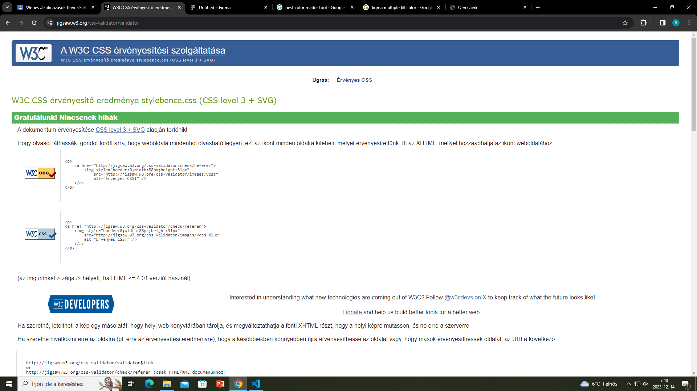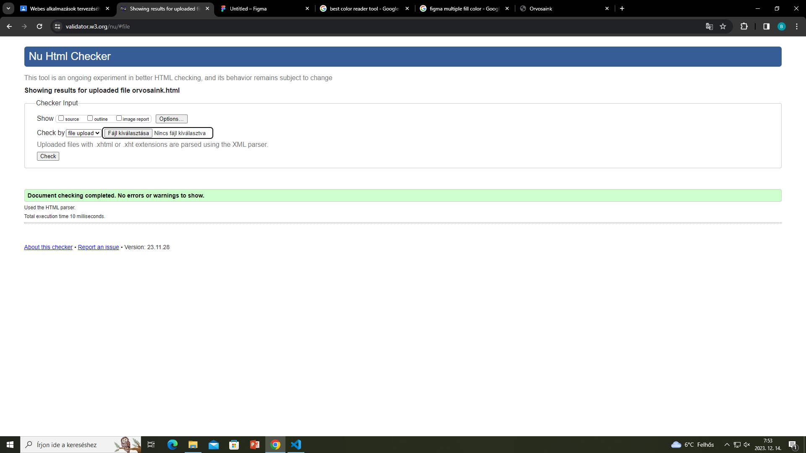

Figma wireframe:

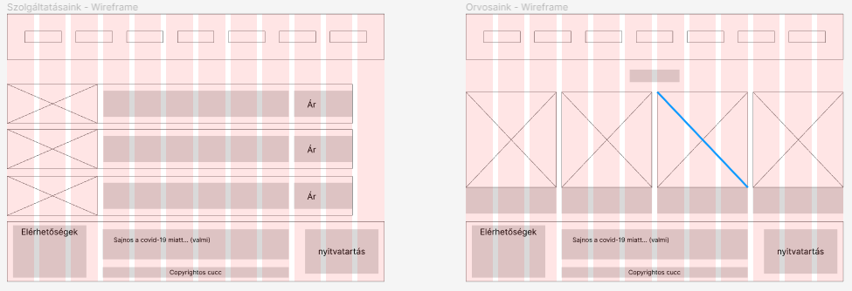

Figma design:

